**WEEK 2**

**Exercises**

**Exercises:**

1. Display the first name, last name, and salary of all Global Fast Foods staff whose salary is between $5.00 and $10.00 per hour.

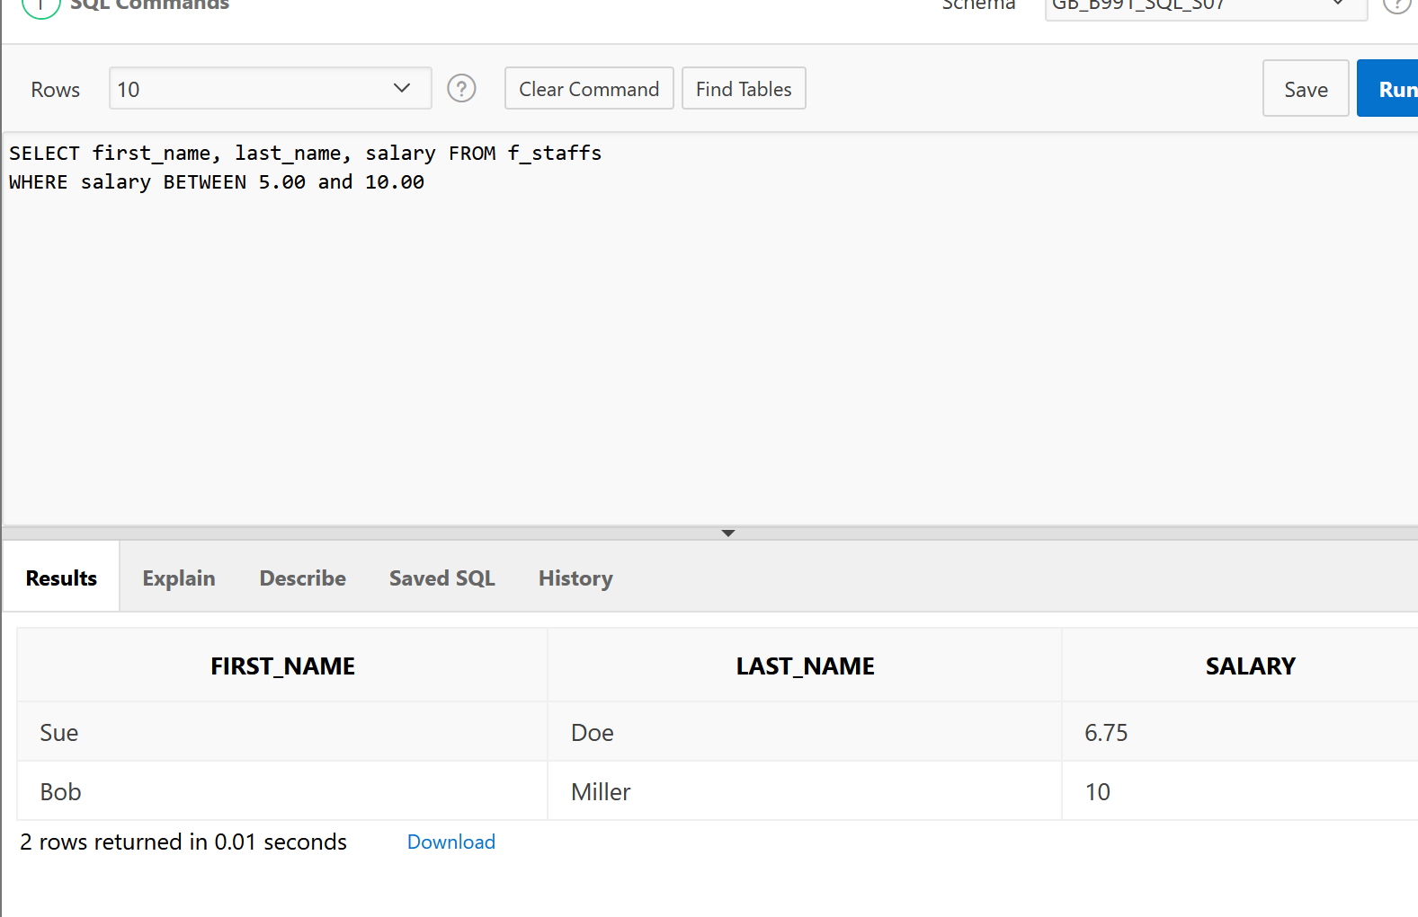

1. Display the location type and comments for all DJs on Demand venues that are Private Home.

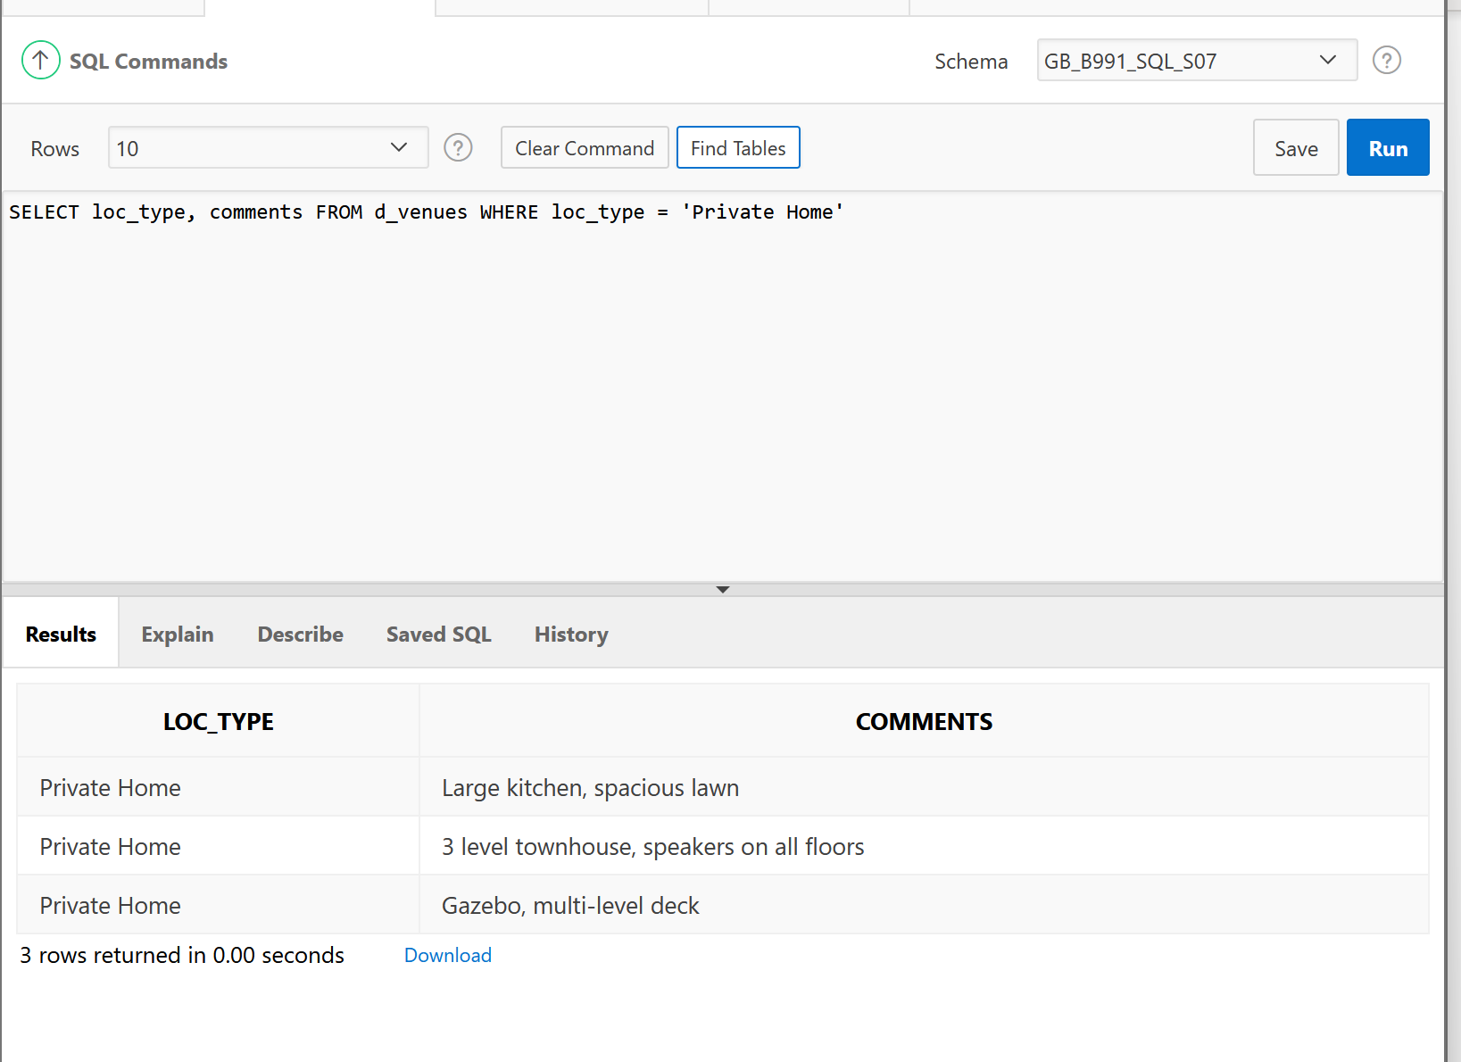

1. Create a list of all the DJs on Demand CD titles that have “a” as the second letter in the title.

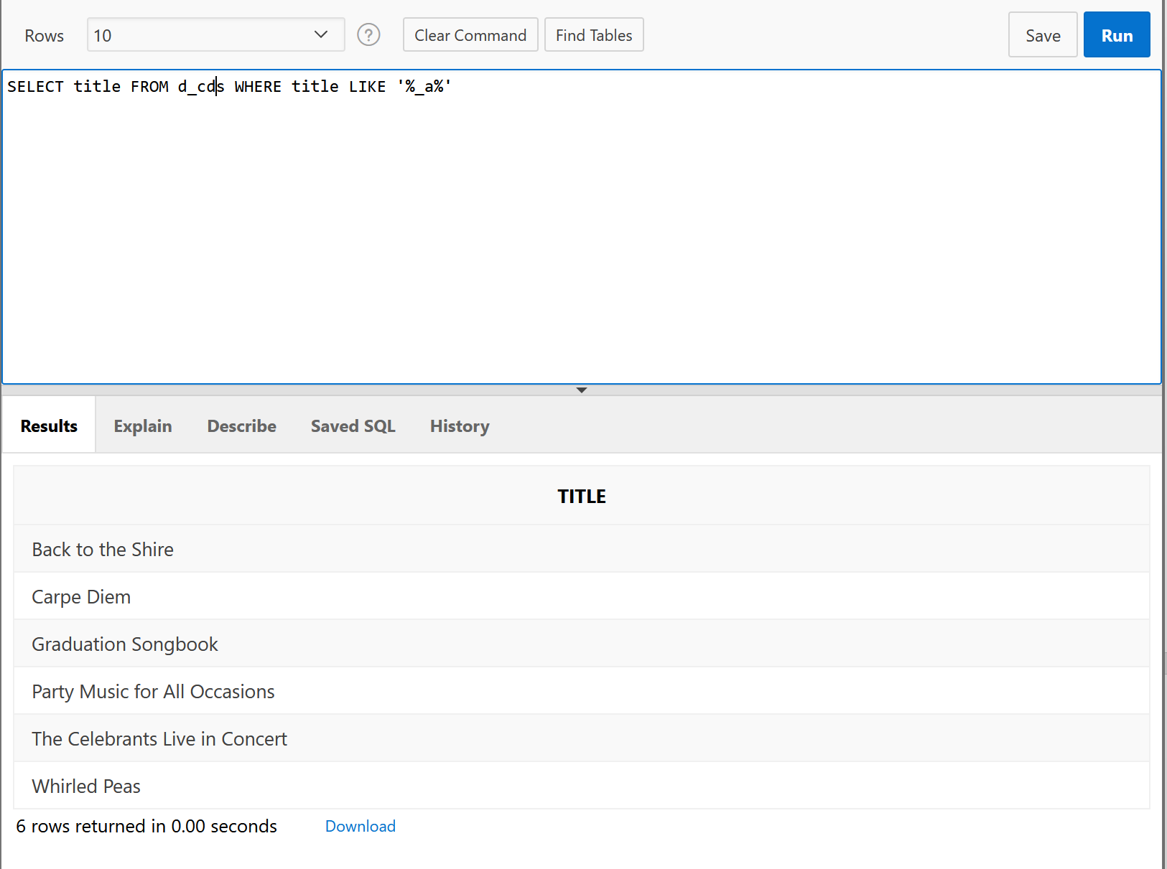

1. Who are the partners of DJs on Demand who do not get an authorized expense amount?

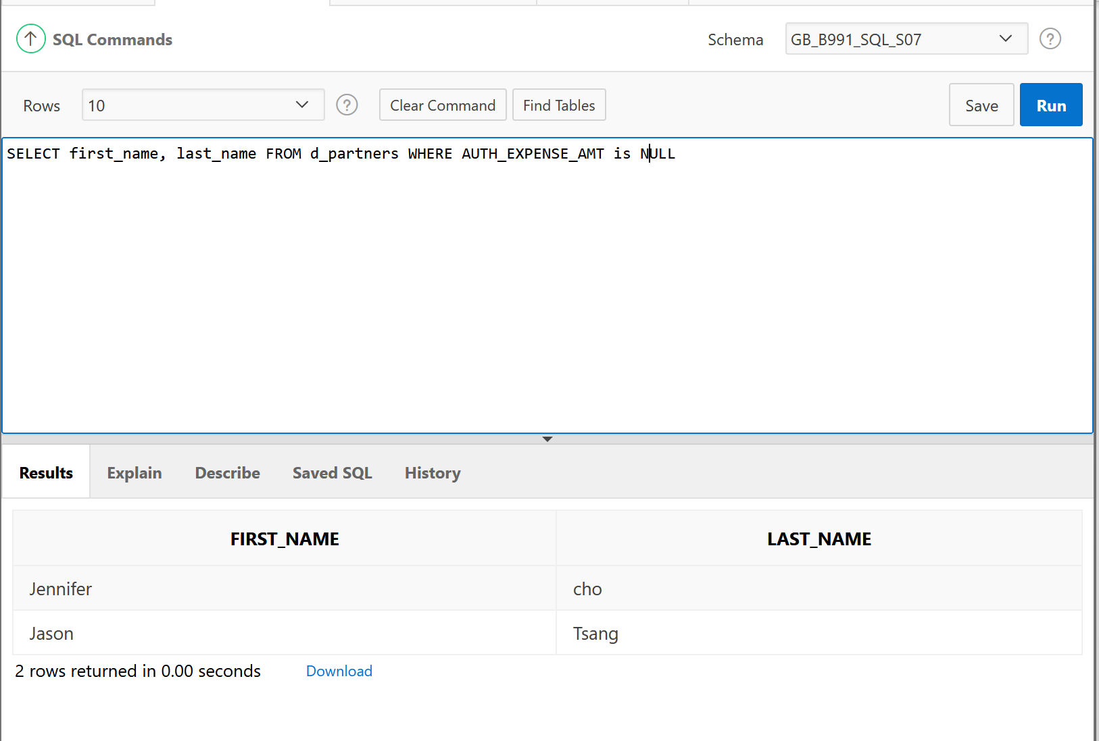

1. Write a SQL statement that lists the songs in the DJs on Demand inventory that are type code 77, 12, or 1.

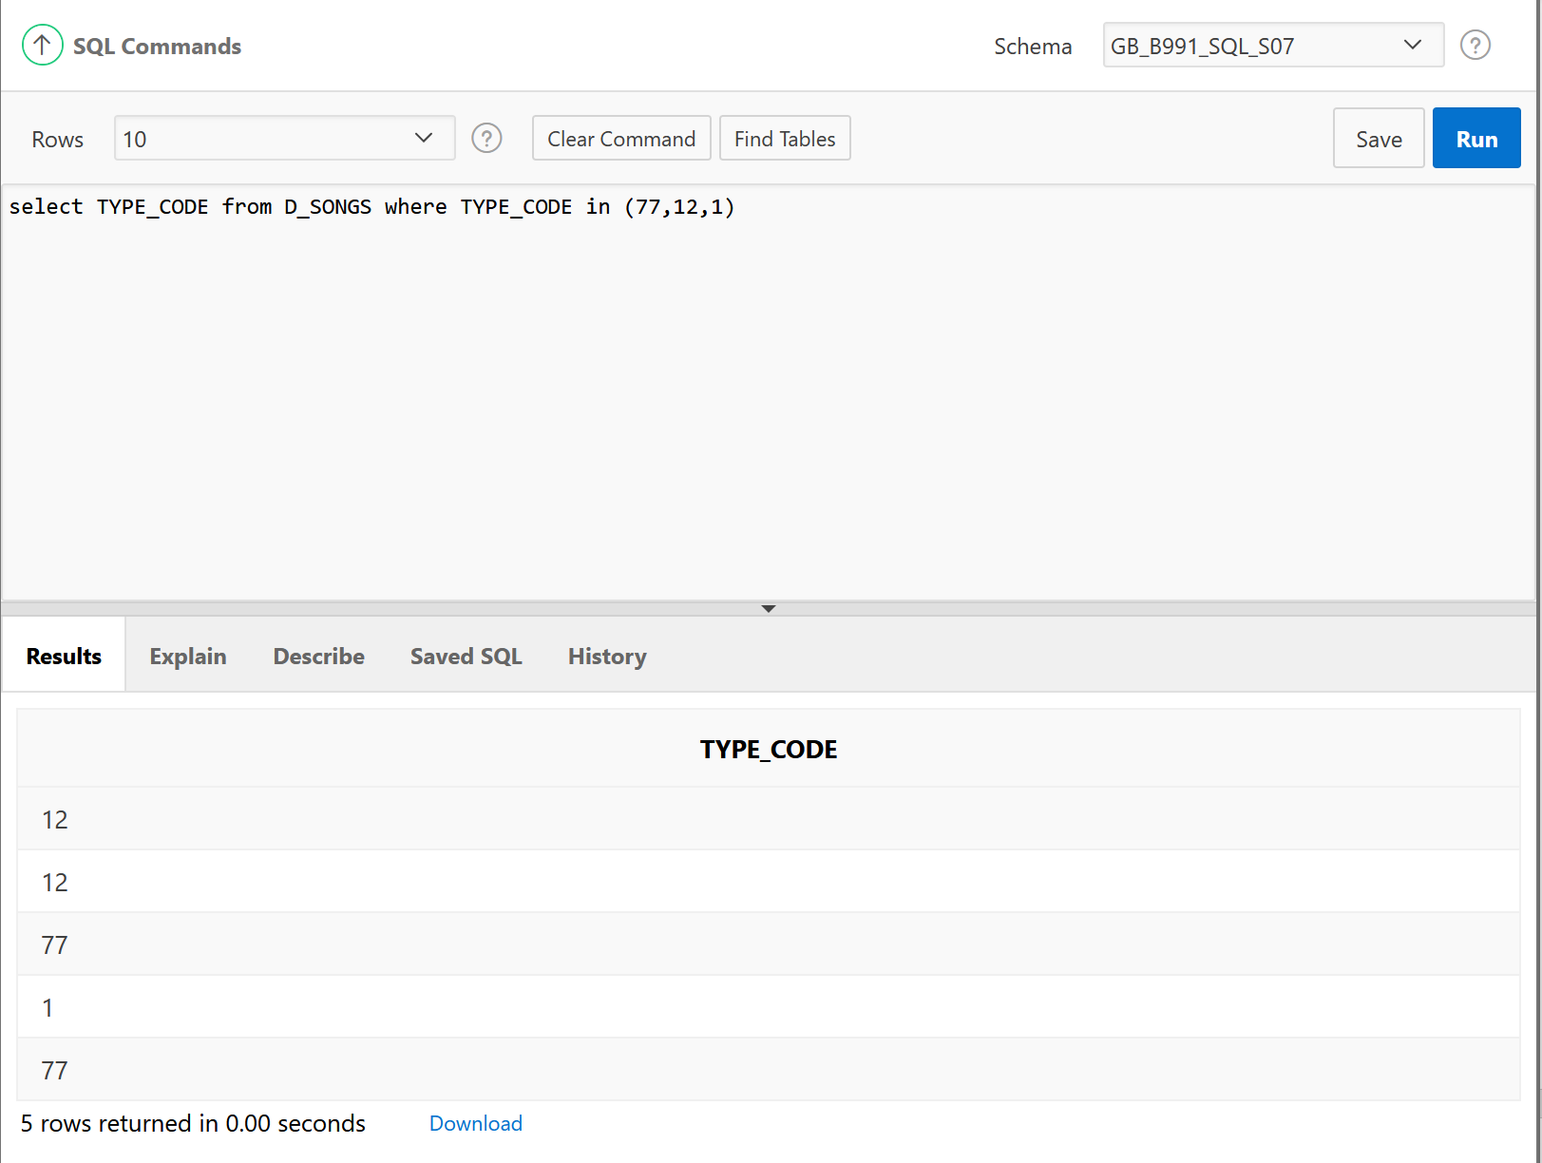

1. Display the last names of all Global Fast Foods employees who have “e” and “i” in their last names.

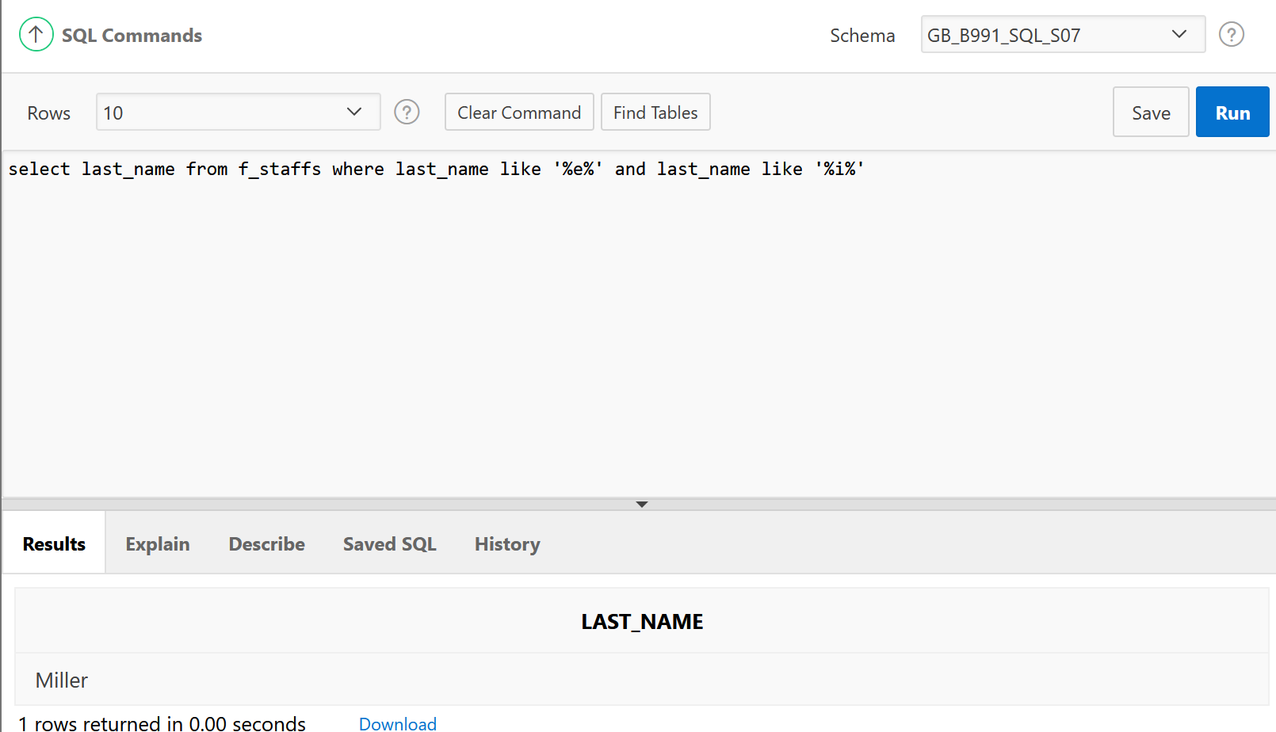

1. “I need to know who the Global Fast Foods employees are that make more than $6.50/hour and their position is not order taker.”

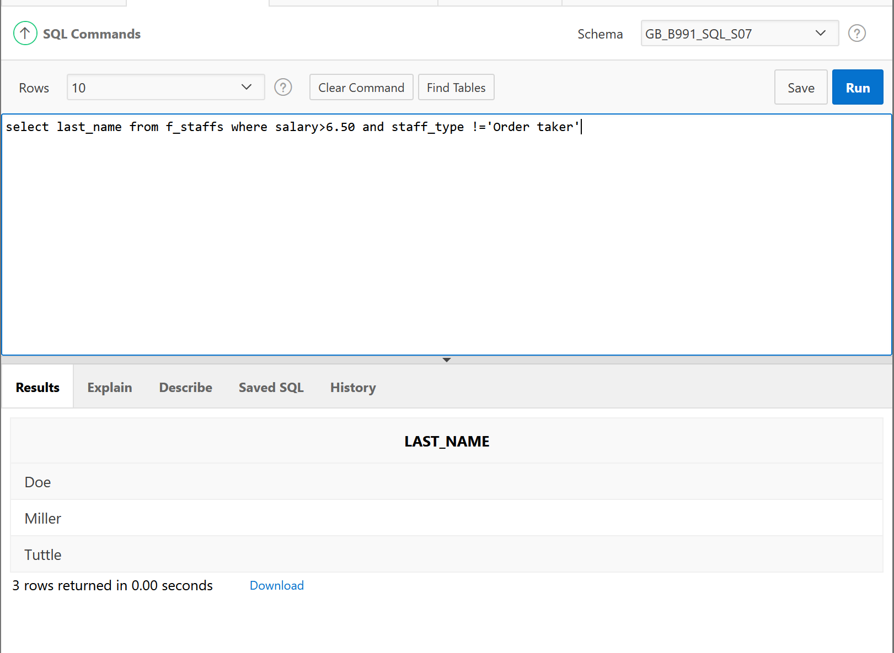

1. In which venues did DJs on Demand have events that were not in private homes?

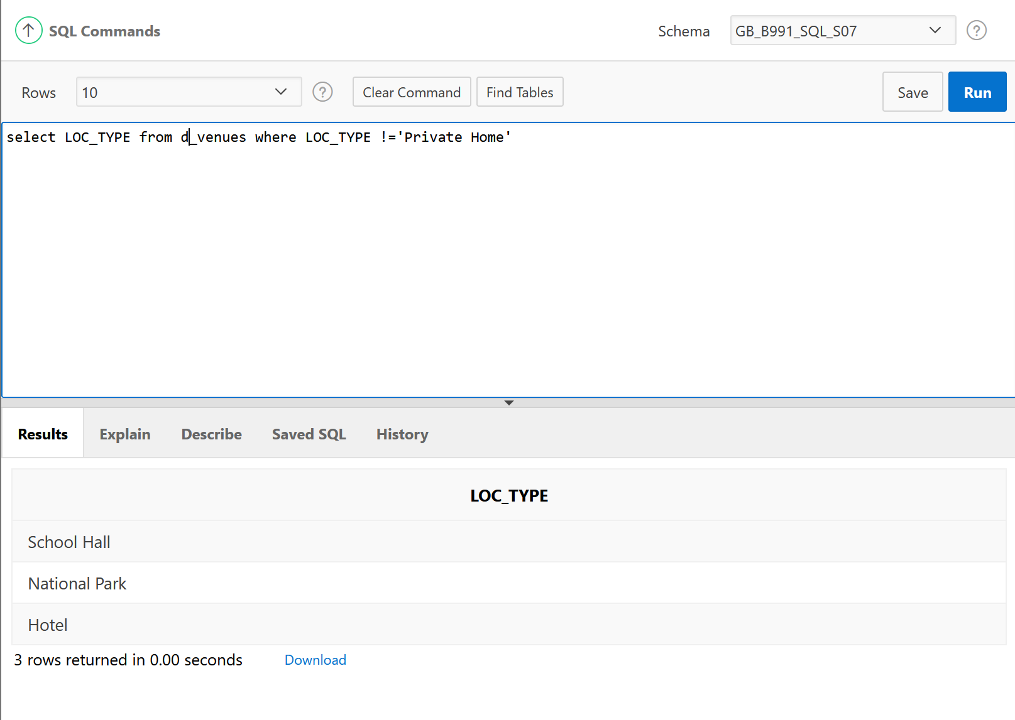

1. Order the DJs on Demand songs by descending title. Use the alias "Our Collection" for the song title.

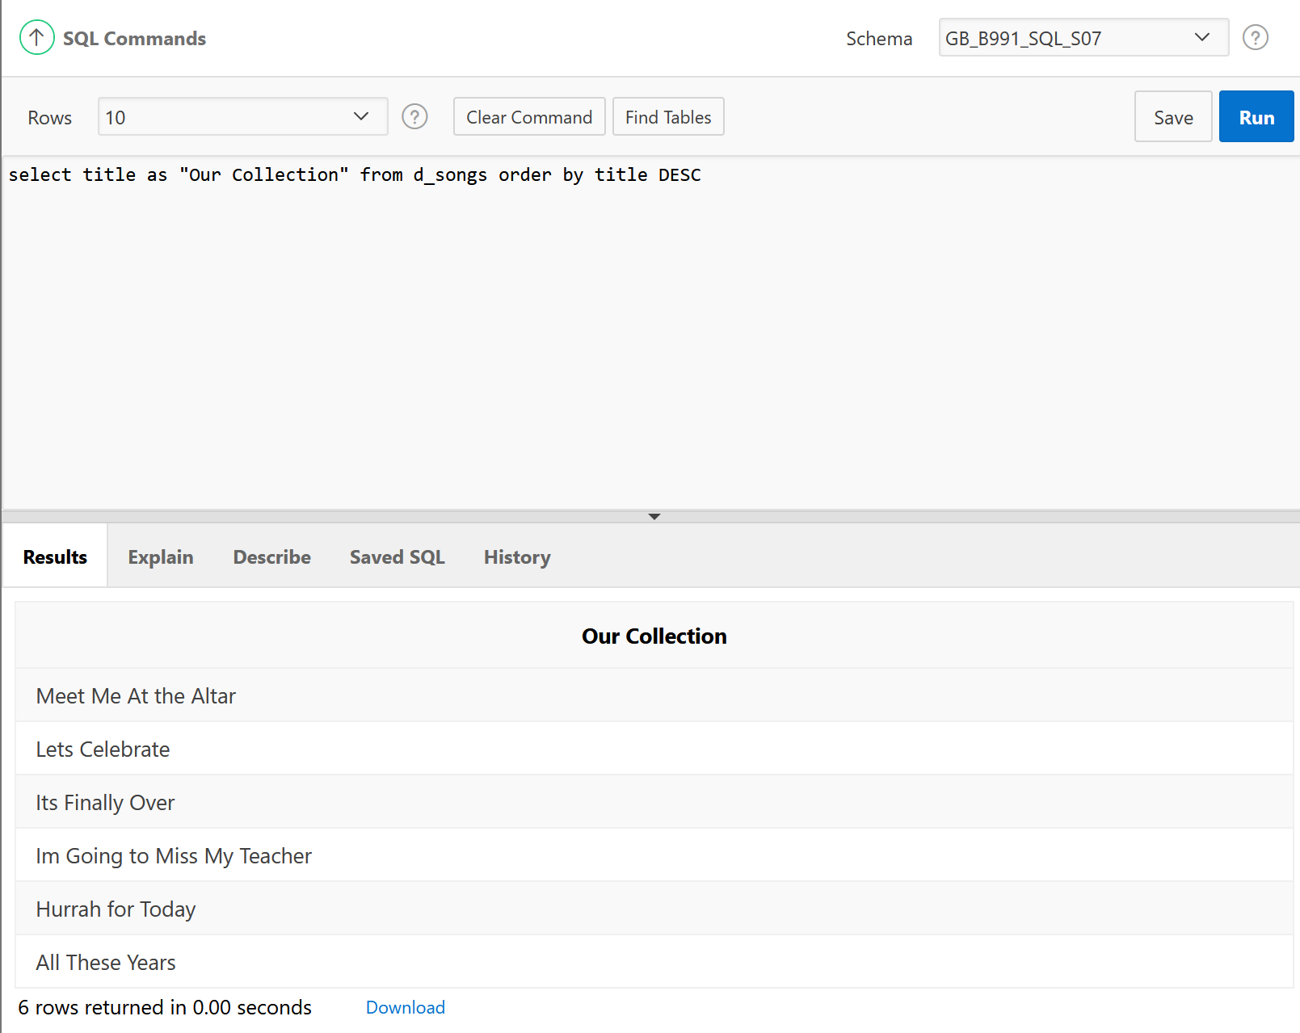

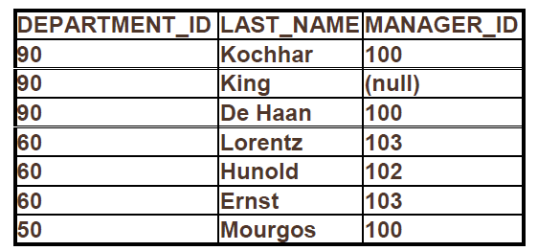

1. Write a SQL statement using the employees table and the ORDER BY clause that could retrieve the information in the following table. Return only those employees with employee_id<125.

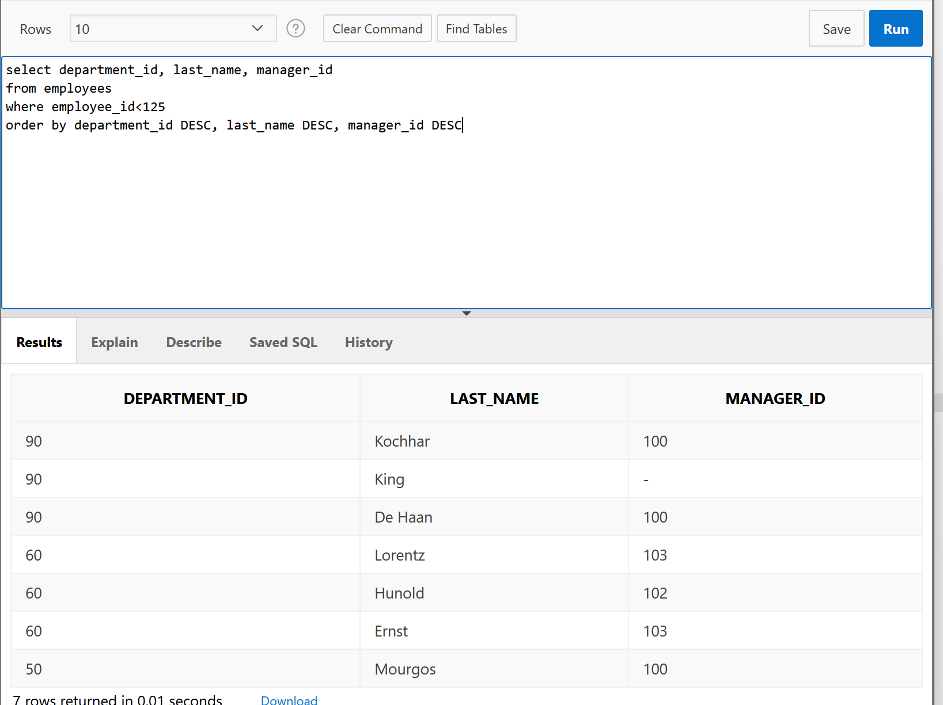

1. Select average, minimum, maximum and the total Salaries for all employees.

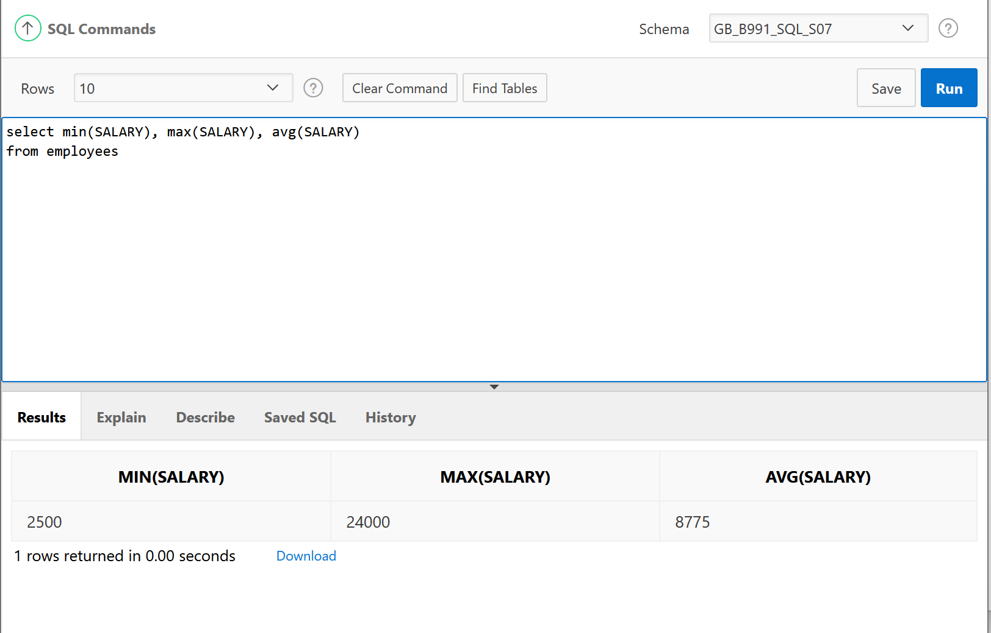

1. Write a query to return the first character of the first name concatenated to the last_name, the salary, and the department id for employees working in department 20. Give the first expression an alias of Name. Use the EMPLOYEES table.

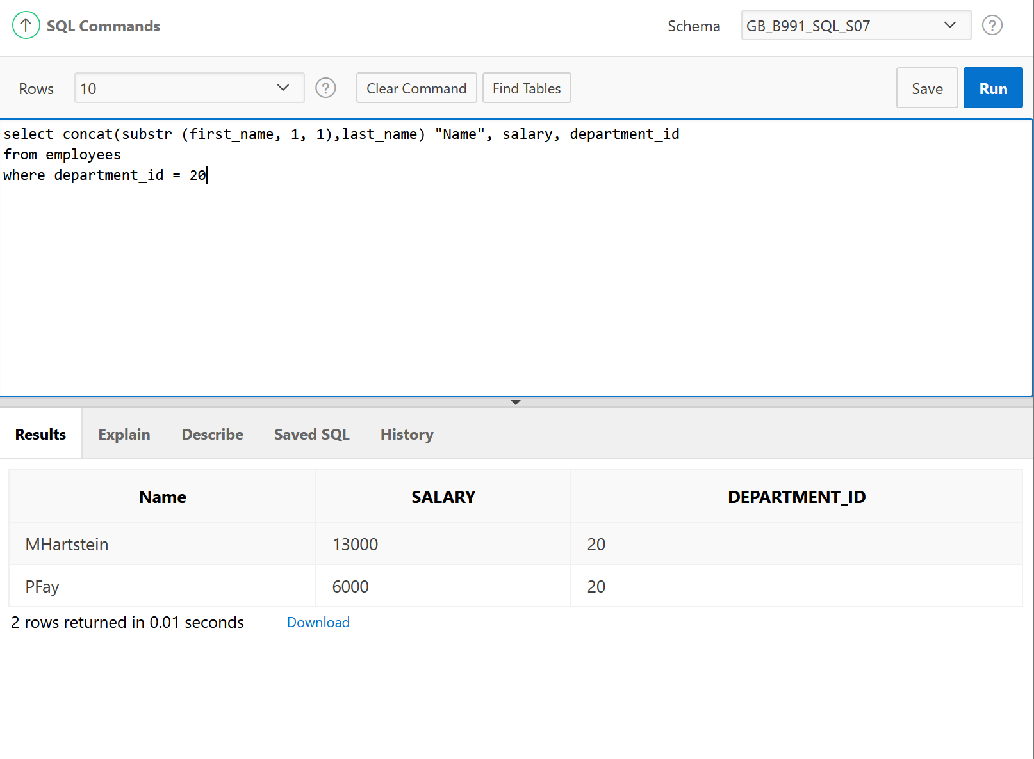

1. Divide each employee’s salary by 3. Display only those employees’ last names and salaries who earn a salary that is a multiple of 3.

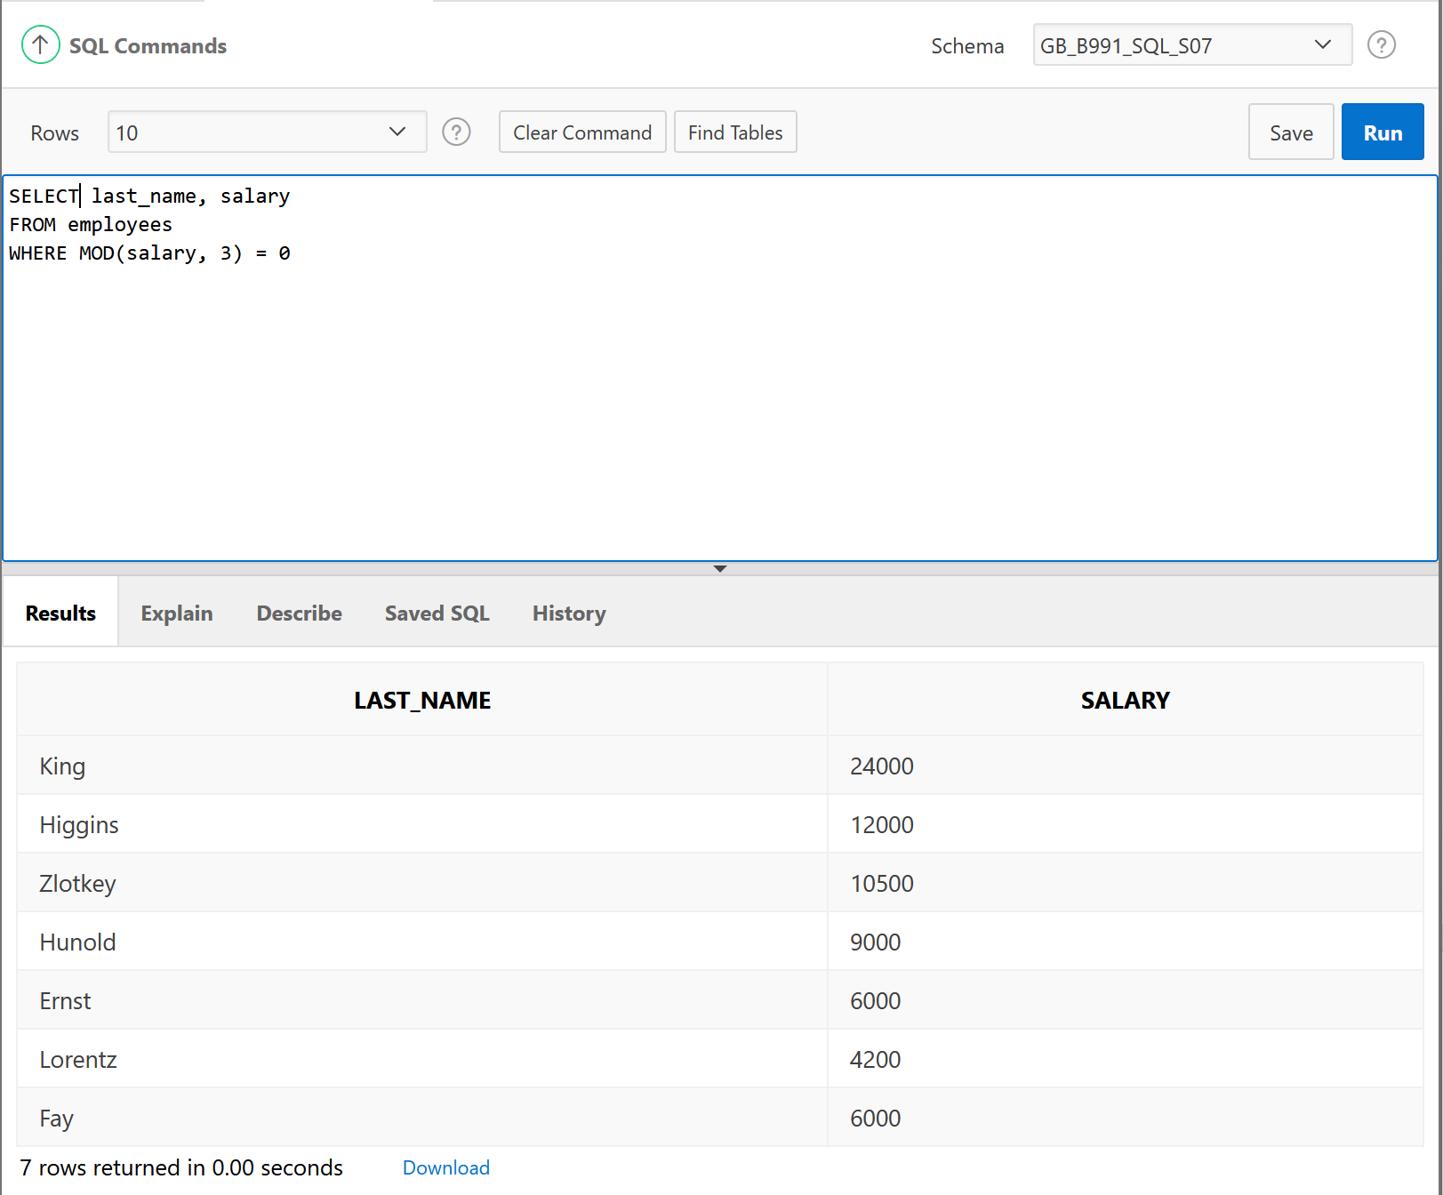

1. For DJs on Demand, display the number of months between the event_date of the Vigil wedding and today’s date. Round to the nearest month.

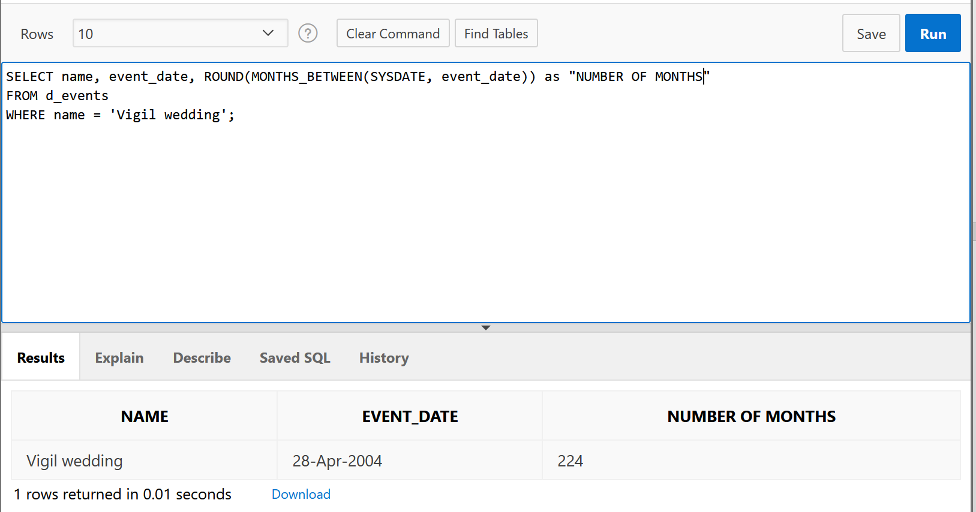

1. What is the last day of the month for June 2005? Use an alias for the output.

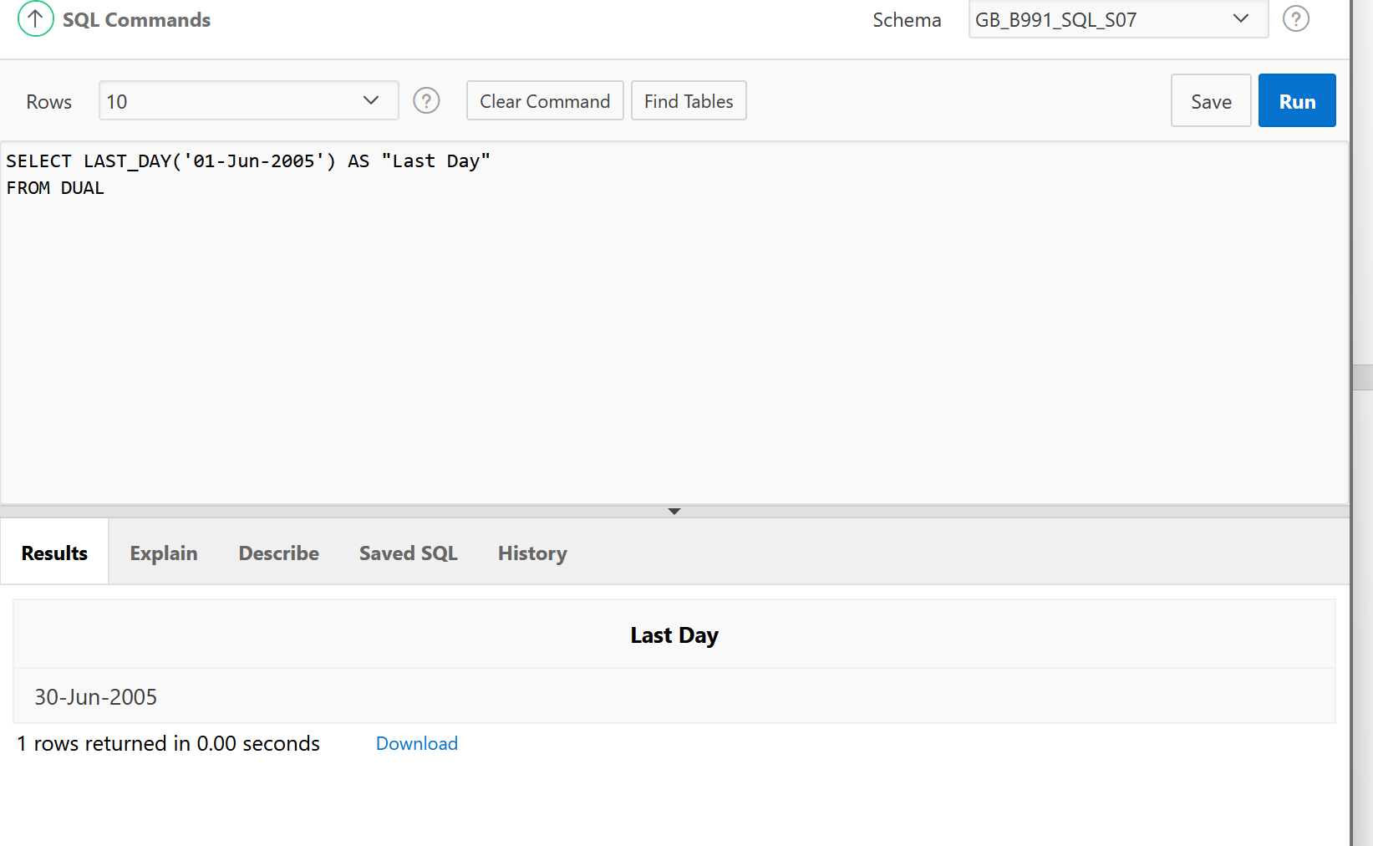

1. How many months between your birthday this year and January 1 next year?

